北航优秀外国留学生奖学金在线申请操作指南（学生）
User Guide of Online Application for Distinguished Foreign Students Scholarship of Beihang University (For Student)

请使用计算机填写。
Please use the computer to complete the online application.

第1步：访问“网上办事大厅”（http://n.buaa.edu.cn），使用统一认证账号（即：每日健康打卡小程序的登录账号）登录。
Step 1：Visit “网上办事大厅” (Online Service Hall)（http://n.buaa.edu.cn） and log in with your unified identity authentication account of Beihang University (the same account you log in to submit your daily health report).

在“网上办事大厅”首页上方搜索框中输入“北航优秀外国留学生奖学金”，点击“搜索服务”。
Type "北航优秀外国留学生奖学金" in Chinese in the search box at the top of the page, and click "搜索服务（Search）".
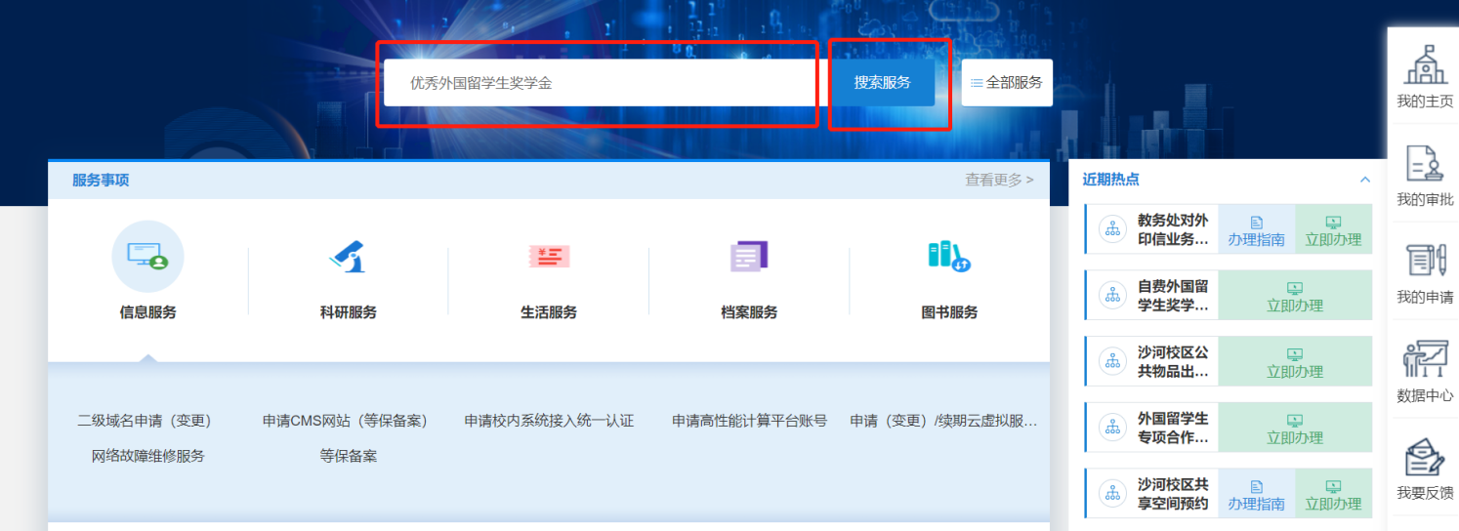

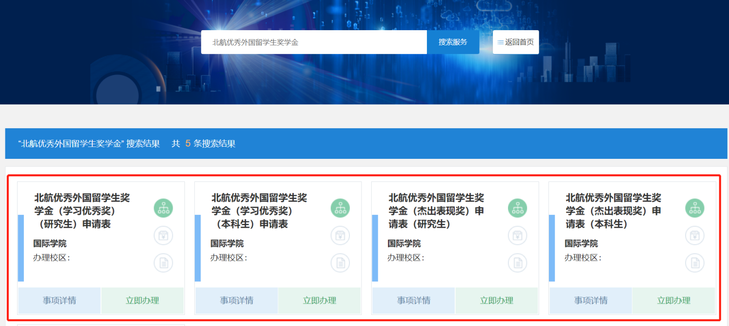

第2步：选择要申请的奖项，点击“立即办理”，进入申请页面。
Step 2: Select the scholarship you want to apply for, click“立即办理”（Apply Now） and enter the application page.

- ①北航优秀外国留学生奖学金（学习优秀奖）申请表（研究生）
Application Form for Distinguished Foreign Students Scholarship of Beihang University (Excellent Study) (Postgraduate)
- ②北航优秀外国留学生奖学金（学习优秀奖）申请表（本科生）
Application Form for Distinguished Foreign Students Scholarship of Beihang University (Excellent Study) (Undergraduate)
- ③北航优秀外国留学生奖学金（杰出表现奖）申请表（研究生）
Application Form for Distinguished Foreign Students Scholarship of Beihang University (Outstanding Behavior) (Postgraduate)
- ④北航优秀外国留学生奖学金（杰出表现奖）申请表（本科生）
Application Form for Distinguished Foreign Students Scholarship of Beihang University (Outstanding Behavior) (Undergraduate)

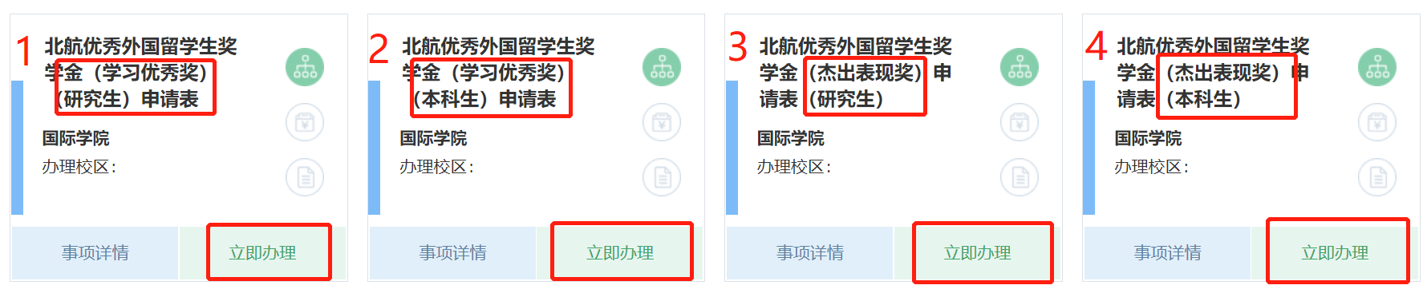

第3步：填写本人在本评审年度内（2022年10月1日至2023年9月30日）的个人情况并上传相关材料。
Step 3: Report your personal statement and achievements in the previous year (from October 2022 to September 2023) and upload the application materials.
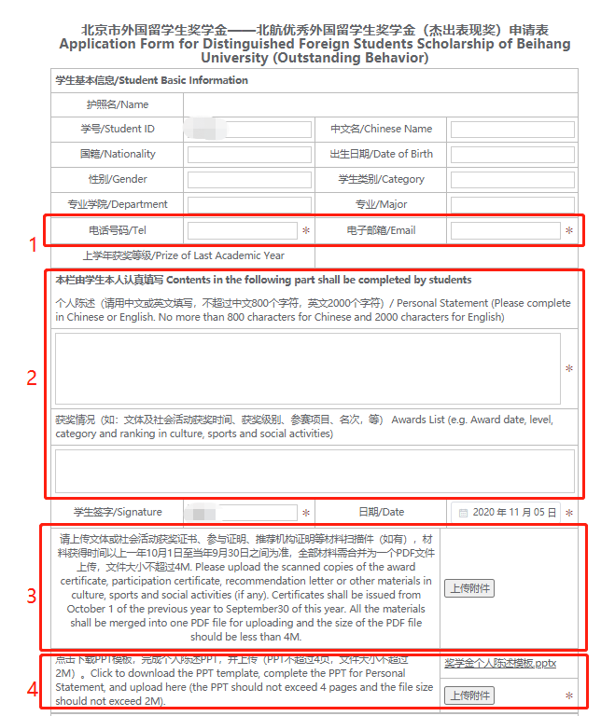

- ①填写本人电话、电子邮箱；Fill in your mobile phone number and email address;

- ②填写本人在本评审年度内（2022年10月1日至2023年9月30日）的个人学习、科研及课外活动表现情况（请用中文或英文填写，中文不超过800个字符或英文不超过1500个字符）；Report your academic study and performance in the previous year (from October 2022 to September 2023) (Please complete in Chinese or English. No more than 800 characters for Chinese or 1500 characters for English);

- ③上传证明材料（如有），材料获得时间以2022年10月1日至2023年9月30日之间为准，全部材料需合并为一个PDF文件上传，文件大小不超过4M. 成绩单由国际学院统一提供，无需在此上传成绩单。Upload the certificates (if any). Certificates shall be issued from October 2022 to September 2023. All the materials shall be merged into one PDF file for uploading and the size of the PDF file should be less than 4M. No need to upload transcript since it is provided by the International School.

- 学习优秀奖：请上传论文的检索证明、录用通知或参与发表专著、专利等学术成果证明材料扫描件（如有）;
Scholarship of Excellent Study: Please upload the scanned copies of the certificates of academic achievements, e.g. paper retrieval or acceptance, monograph publication or patents (if any);

- 杰出表现奖：请上传文体或社会活动获奖证书、参与证明、推荐机构证明等材料扫描件；
Scholarship of Outstanding Behavior: Please upload the scanned copies of the award certificate, participation certificate, recommendation letter or other materials in culture, sports and social activities;

- ④点击下载栏目右侧的“奖学金个人陈述模板”PPT，完成个人陈述PPT，并上传（PPT不超过4页，文件大小不超过2M）。Click to download the PPT template first, complete the PPT for Personal Statement, and upload here (the PPT should not exceed 4 pages and the file size should not exceed 2M).

第4步：点击页面右上角“正式提交”（Submit），“确定”（Confirm），完成填报。
Step4: Click “正式提交”（Submit）and “确定”（Confirm）to complete the application.
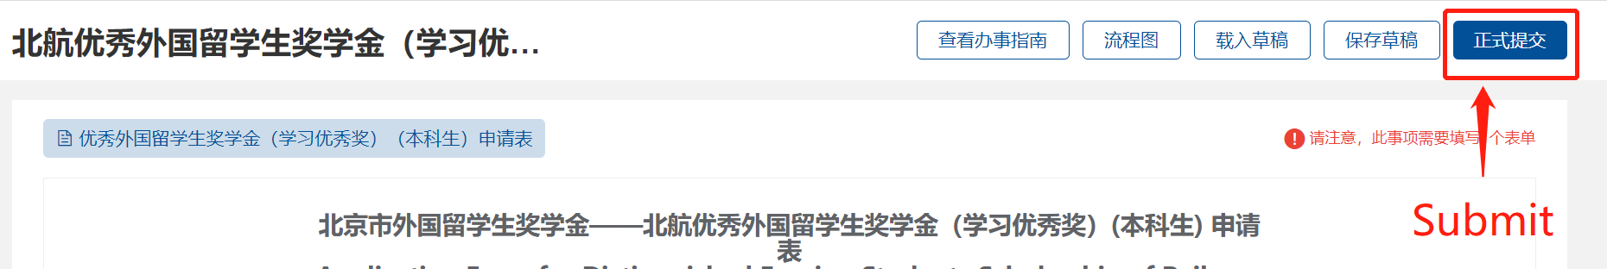

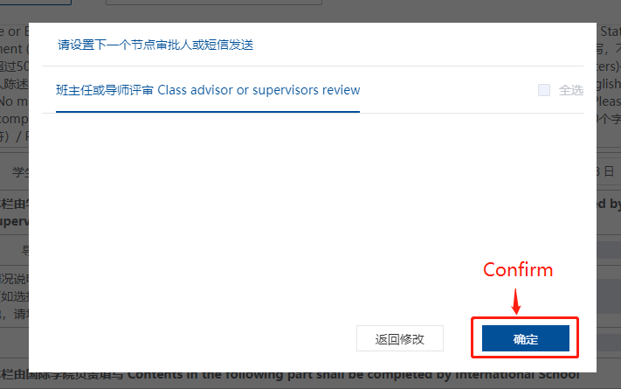

附： 北航优秀外国留学生奖学金在线申请 温馨提示
Tips on Distinguished Foreign Students Scholarship Online Application

- 如何查看申请是否提交成功和线上评审的进度
How to check the application submission status and the review progress online

提交成功后，可依次点击“网上办事大厅”首页右侧①“我的申请”→②“我的申请”：进行中→③“处理记录”或“流程跟踪”，查看线上评审进度。
绿色框中的时间：表示成功提交的日期和时间。
蓝色框中的内容：表示当前的评审进度。

After submission, you can click①"我的申请"(My Application) on the right side of the homepage→②"我的申请"：进行中(My Application: In Progress)→③“处理记录”或"流程跟踪”(Review Record or Process Tracking)to check the progress of your application review process.
Time in the green box indicates the date and time of your submission.
Content in the blue box indicates the current review process.
